
DORMANSAND NEIGHBOURHOOD PLAN
LOCAL GREEN SPACES REPORT
January 2017, updated April and December 2025

This report has been prepared for the purposes of, and to accompany, the “submission” version of the emerging Dormansland Neighbourhood Plan. This report sets out the conclusions of the original Steering Group, and approved by Dormansland Parish Council, as to which sites should be designated as Local Green Spaces and the reasons for doing so. It follows the assessment by the Steering Group and its specialist Sub-Groups of a number of potential Local Green Space sites within Dormansland Parish and takes account of the responses received during public engagement and consultations.

NATIONAL PLANNING POLICY FRAMEWORK
In order for a site to qualify for designation as a Local Green Space, it must meet each of the criteria set out in paragraph 107 of the National Planning Policy Framework (NPPF 2024, updated 2025). These require that the site in question is:

- in reasonably close proximity to the community it serves;
- demonstrably special to a local community and holds a particular local significance, for example because of its beauty, historic significance, recreational value (including as a playing field), tranquility or richness of its wildlife) and
- local in character and is not an extensive tract of land.

The Planning Practice Guidance Online Document has been used for further clarification for designation criteria.

PRINCIPLES ADOPTED
The proposed sites considered for potential designation as Local Green Spaces fall into one (or more) of four distinct categories:
- those (generally small) areas of Dormansland within its “built environment”, which are considered most vital to its open, rural feel;
- those sites used for sports and other recreational activities;
- those on the immediate periphery of the settlement with public access and in regular use by those on foot; and
- those which (without necessarily offering public access) fulfil a specific function to the local community, that is reflected in the aspirations and policy objectives of the emerging Dormansland Neighbourhood Plan.

The local sites that are most demonstrably special to the community are now being proposed for designation as Local Green Space in the “submission” version of the Dormansland Neighbourhood Plan, as they could be potential sites for future small scale development that would be detrimental to the existing environment and community. Without the additional protections in place to maintain all or part of the Green Spaces which have a special relationship with the community, they could be lost forever. Early and ongoing community engagement supports the inclusion of the sites listed below.

One of the sites is not in public ownership but is crossed by very well used public rights of way between the village and the station and has had its value to the community confirmed through public engagement.

Other open spaces within the parish area have been identified by Tandridge District Council in their Open Space Strategy 2021 – 2025. Many are not included in this assessment because they are not in close proximity to the village residents or they are sufficiently protected through their ownership by Surrey Highways, Educational facilities or are integral features of the two village churches (graveyards/ garden).

DESIGNATED SITES: COMPLIANCE WITH THE NPPF

The following designated sites meet the criteria set out in paragraph 107 of the National Planning Policy Framework (2024, amended 2025).

- Newhache Green
- Dormansland Recreational Ground including the tennis courts.
- The New Farthingdale Green
- Colin Anderson playing field
- Dormansland Cricket ground
- Station Fields

The map below shows these proposed sites, numbered in red.

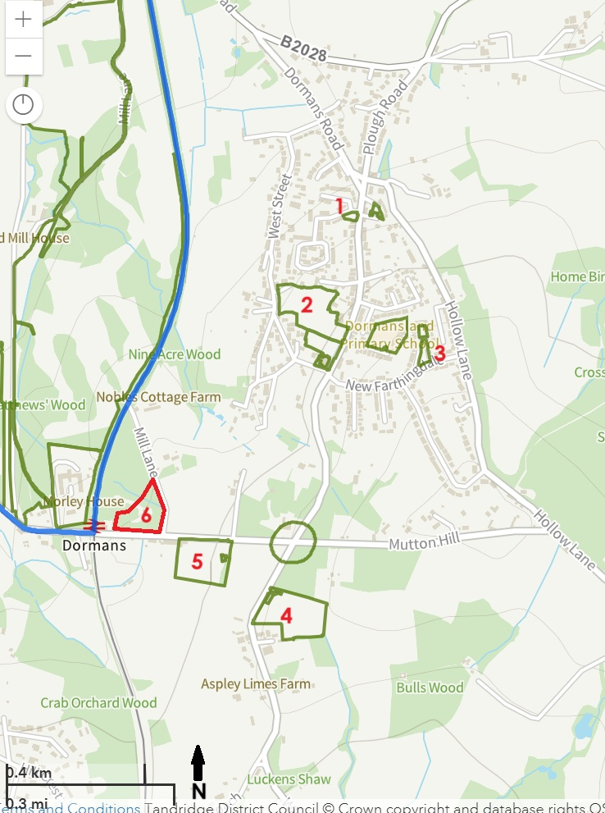
From Tandridge District Council Planning Search Map with “Open Spaces” outlined in dark green https://tdcmaps.tandridge.gov.uk/myHouse/myHouse_map.html

Our Local Green Space Criteria
- All the sites must reasonably close proximity to the community (The land must not be isolated from the community and would normally be within easy walking distance of the community served.)

- All the sites must meet the following criteria:-

  - Land is not subject of a planning permission for development
  - Space is not allocated or proposed for development in the Local or Neighbourhood Plan.
  - The space is demonstrably special to the local community and holds particular local significance.

- All the sites must meet at least one of the following criteria as being demonstrably special to a local community:-

  - Beauty: This relates to the visual attractiveness of the site, and its contribution to landscape, character and or setting of the settlement. LGS would need to contribute to local identity, character of the area and a sense of place, and make an important contribution to the physical form and layout of the settlement.
  - Historic significance: The land should provide a setting for, and allow views of, heritage assets or other locally-valued landmarks. The land could have an important local historical connection. It may be necessary to research historic records from the County Archaeologist or National or Local Records Office.
  - Recreational value: It must have local significance for recreation, perhaps through the variety of activities it supports, and be of value to the community.
  - Tranquillity: It must have the capability to offer an oasis of calm and a space for quiet reflection or to pause on a journey to rest quietly.
  - Richness of wildlife: This might include the value of its habitat, and priority areas may have been identified by the council. It may require some objective evidence, such as a designation, like a wildlife site or Local Nature Reserve.

4. The space is not an extensive tract of land and is local in character

The initial assessment against the above criteria are shown in the table below:
Ref | Site name | Area | Criteria Measures
 |  | (Ha) | 1 | 2 |  |  | 3 |  |  |  |  | 4
 |  |  |  | a | b | c | a | b | c | d | e
1 | Newhache  Green | 0.08
2 | Dormansland Rec. Ground | 2.02
3 | New Farthingdale Green | 0.15
4 | Colin Anderson Field | 2.02
5 | Dormansland Cricket Ground | 1.78
6 | Station  Fields | 2.05

Colour  Coding Key | Meets the criteria very well |  | Meets the criteria reasonably well |  | Doesn’t meet the criteria very well |  | Doesn’t meet the criteria at all

All the sites meet the criteria in varying degrees, as indicated by the colour shading.
In the following pages of the report, we examine the particular characteristics of each parcel of land, on a site-by-site basis, with photographs and supporting commentary.

Site 1 - Newhache Green
The green at the junction of Newhache with Dormansland High Street.

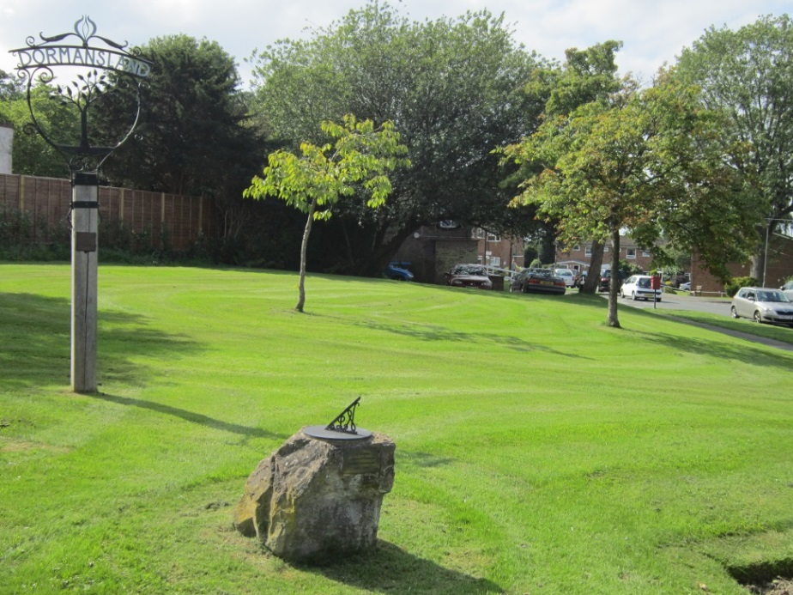

Newhache Green, Dormansland, looking west into Newhache with council housing visible nearby.
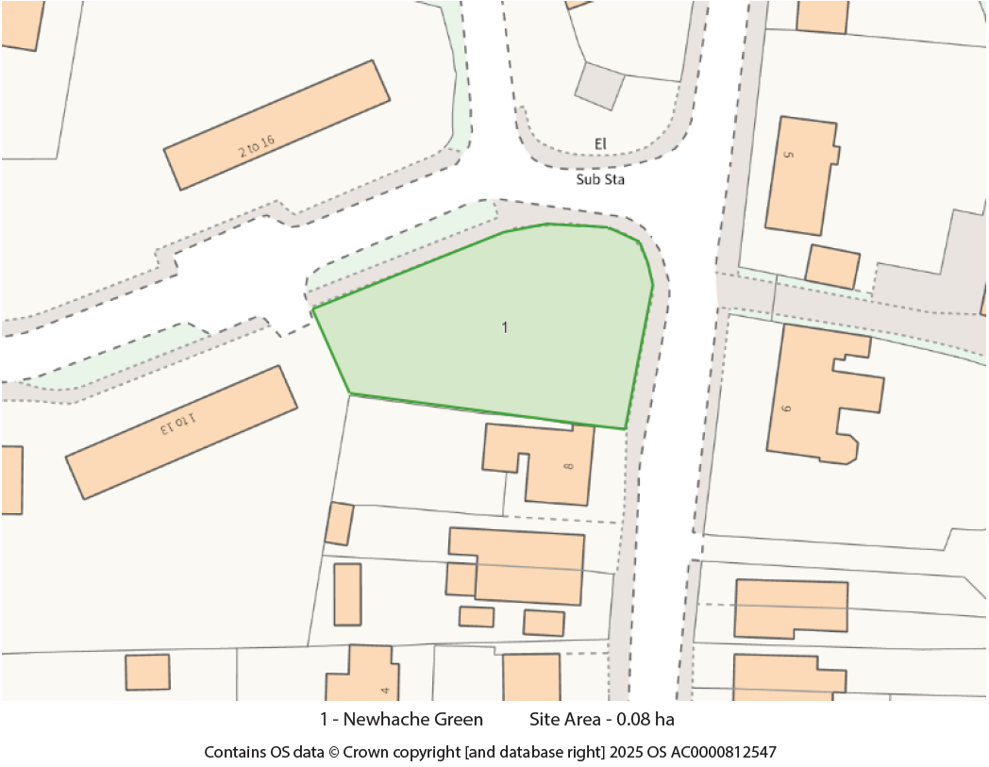
Newhache Green – Location and extent
History
The green was originally created as an amenity area when the sheltered housing flats were built in 1959. Some of the sheltered accommodation does not have individual amenity space, and shared space like the Green are an integral part of the development. The sheltered housing category has now been largely replaced with general purpose council housing.

The village sign erected at the time of the development in its current location is roughly at the geographical centre of the village.

Assessment
Beauty (3a), Recreational Value (3c) and Tranquillity (3d).
The site is located on a gentle slope across the corner of the two roads. The grass is cut professionally, and the flower beds are maintained by volunteers. It has some specimen trees, including spring flowering. Several memorial trees have been planted to commemorate significant events such as the Queen’s Jubliee. There is a community flagpole which is also used for commemorative flags.

The site sits at the north end of Dormansland High Street and provides a focal point and a ‘village green’ feel with the wrought iron village sign. It is grassed with some specimen trees, rose beds, a commemorative sundial and a bench seat. It is used by the residents of Newhache and others as a meeting point, as well as a place for rest and reflection. It has a value as a resting place for pedestrians walking to the village shop from the northern end of the village. Locally organised displays of arts and crafts embellish the trees and posts, highlighting community events, notable dates and during Covid, community support.

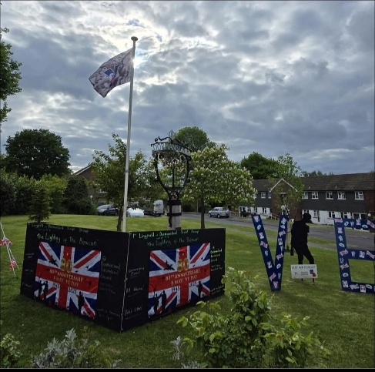
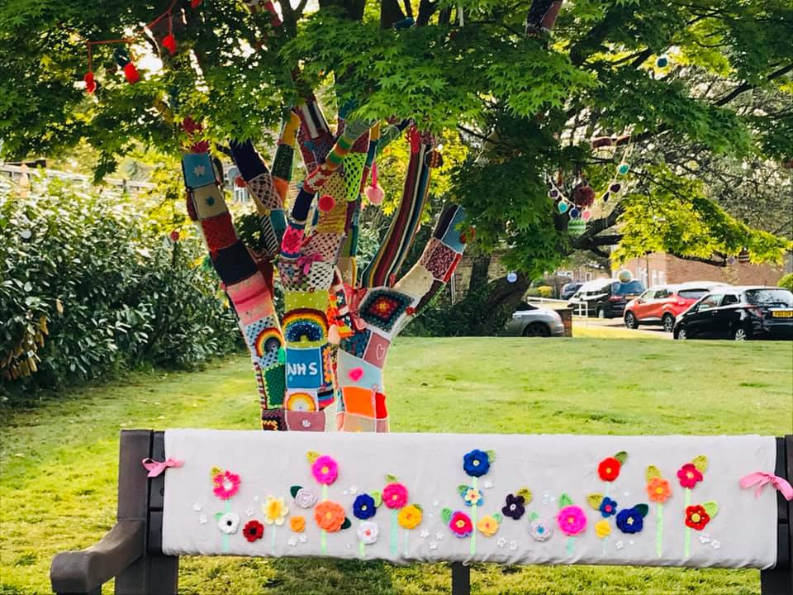

Photos showing “Covid” community knitting and VE celebration displays

Site 2: Dormansland Recreational Ground.

Land between the High Street and West Street, adjoining St John’s churchyard.
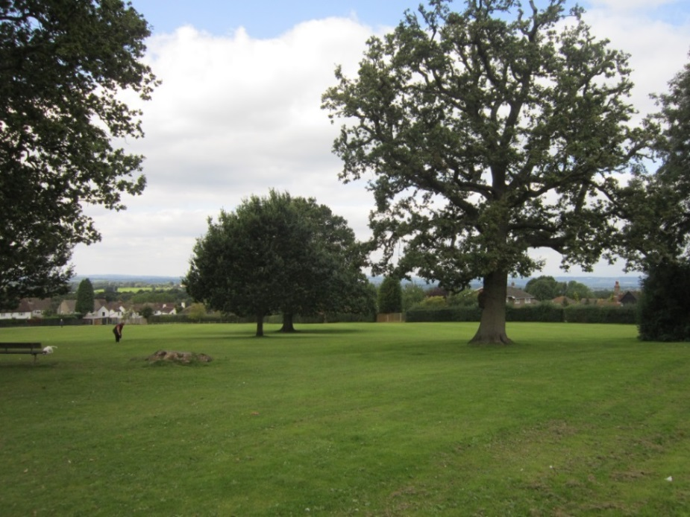
Dormansland Recreation Ground looking north from the tennis courts.

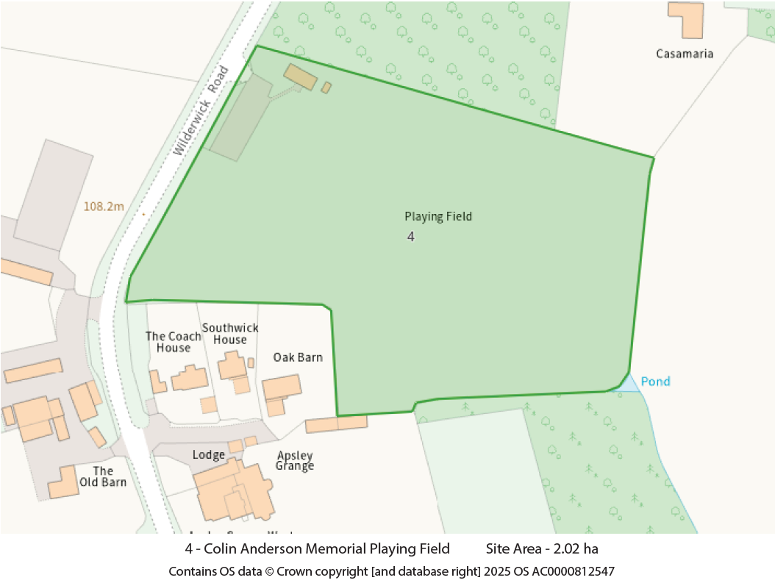
Dormansland Recreation Ground – Location and extent

History
The recreation ground is situated on what was originally part of Dormansland Common land, which dates back to medieval times. There are far reaching views across Lingfield and the Surrey Hills AONB.

Assessment
Beauty (3a), Recreational Value (3c) and Tranquillity (3d)
Dormansland Recreation Ground is managed by Tandridge District Council
and includes a children’s playground, an outdoor gym, two tennis courts and a large open space. The site hosts five ancient oak trees and several other mature trees. The recreation ground is widely used by the community for social and recreational purposes, with sufficient space for active use to coexist alongside those wishing to sit and enjoy the tranquillity and the far-reaching views. Families with young children and school children benefit from the safe space away from traffic to run and play. It hosts village events, such as the Jubilee celebrations, beacon lighting and the annual village carnival.

The Recreation Ground continues to be developed with improvements, with new trees being planted, including for commemorative events and a planned upgrade to the play equipment to provide a fully inclusive play area is in progress.

Site 3: The Green at New Farthingdale
This is an area of community open space between three residential roads of New Farthingdale.

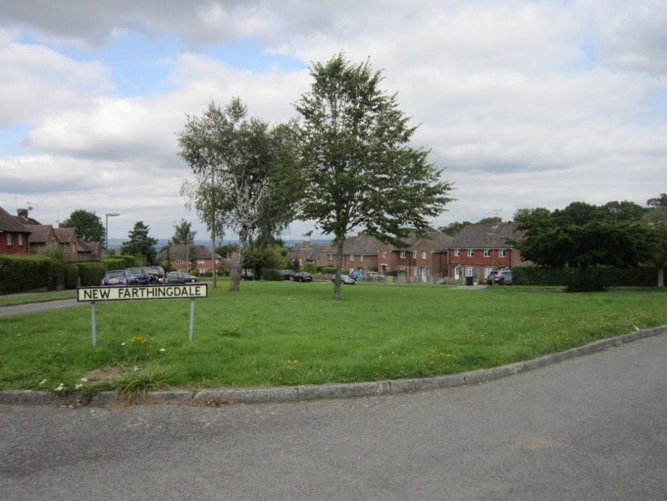
New Farthingdale Green, Dormansland
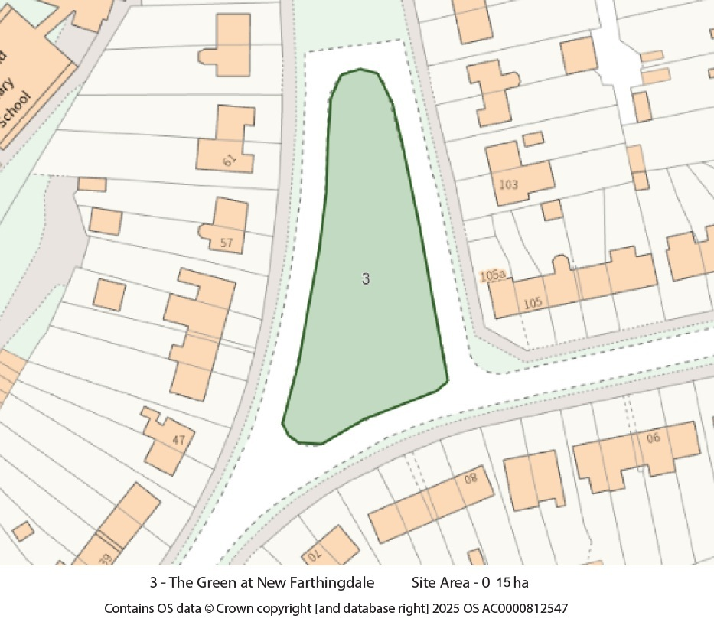
The Green, New Farthingdale – Location and extent
History
The green was created when the Farthingdale estate was built in 1953.

Assessment
Beauty (3a) and Recreational Value (3c)
This is a valued area of community open space, is largely maintained by Surrey County Council, but with support from Dormansland Parish Council. It has far-reaching views towards the Surrey Hills and is close to the village edge, which abuts the High Weald National Landscape to the east. The designated area extends to 0.15 hectare which serves as a green setting for the planned housing estate, providing a sense of place for residents.

It is grassed with some well-spaced trees and is a welcome green space used as a play-area by local children. There is a pedestrian entrance to Domansland School in the north-west corner of New Farthingdale.
Planning permission was granted for part of the original green to be made into a car parking area to compensate for the loss of garage and parking area to the northeast of the green for the construction of 4 new council homes (TA/2022/1638). This remaining open space is now more valuable for the existing residents as well as for the new families who will move into the new flats.

Site 4: Colin Anderson Memorial Playing Field
The Colin Anderson playing field is in the Wilderwick Road, on the southern edge of the village.

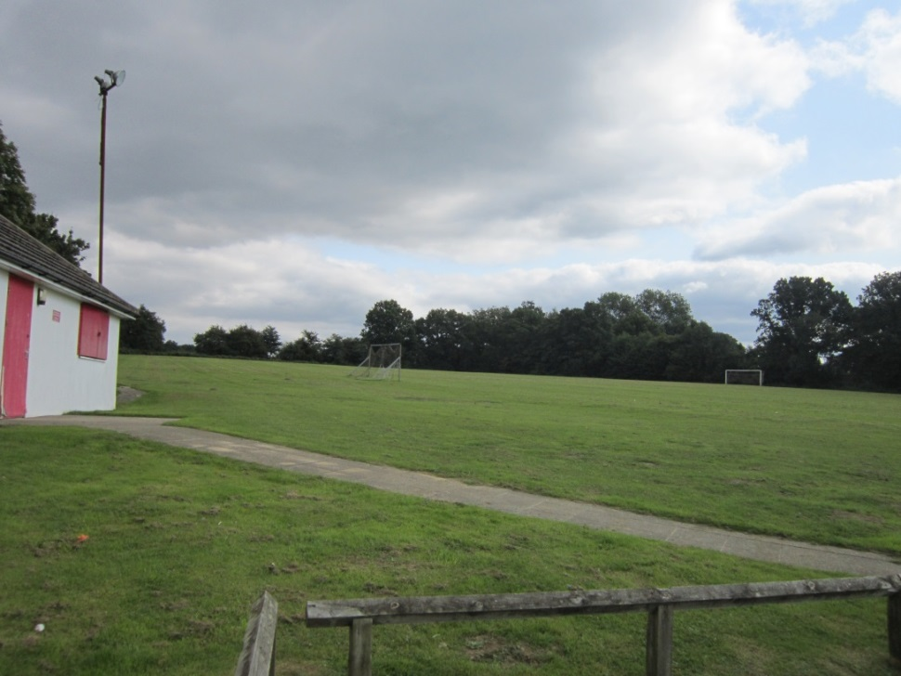
Colin Anderson Playing field, Wilderwick Road, Dormansland
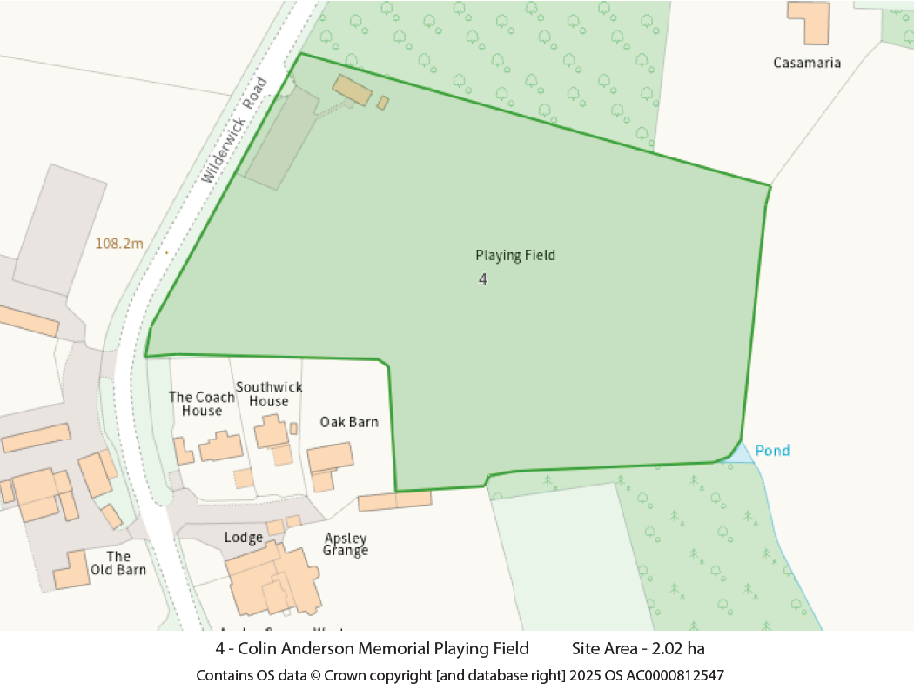
Colin Anderson Playing Field – Location and extent

History
On 22nd November 1948 Lt Col Ian Anderson MC presented a parcel of land, to the rural district council, for the benefit of the villagers of Dormansland, in the memory of his son Colin Daintry Anderson. A trust was setup to administer the land and is a registered charity.

Assessment
Beauty (3a), Recreational Value (3c) and Tranquillity (3d)
The Colin Anderson playing field has full size grass football pitches, a training area and a pavilion with toilets. The site is used by the Rockets Football Club, for matches in the Mid-Sussex league and as a training ground at weekends. The field is set within the High Weald National Landscape (AONB) and offers views and maintains the sense of openness for the area. Although there are no designated public rights of way, the public have free access to walk the perimeter, and this is also a popular dog walking location. The hedges and tees around the field support a wide range of wildlife and provide habitat connectivity within the quiet open countryside.

Site 5: Dormansland Cricket Club, St Clair’s field.
The cricket club site is on the south side of Station Road, Dormansland
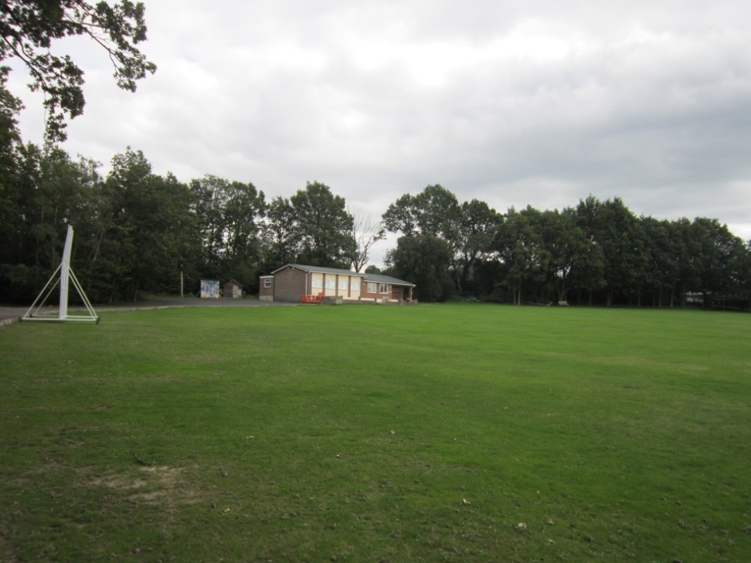
Dormansland Cricket Club, St Clair Cricket ground, Station Road, Dormansland

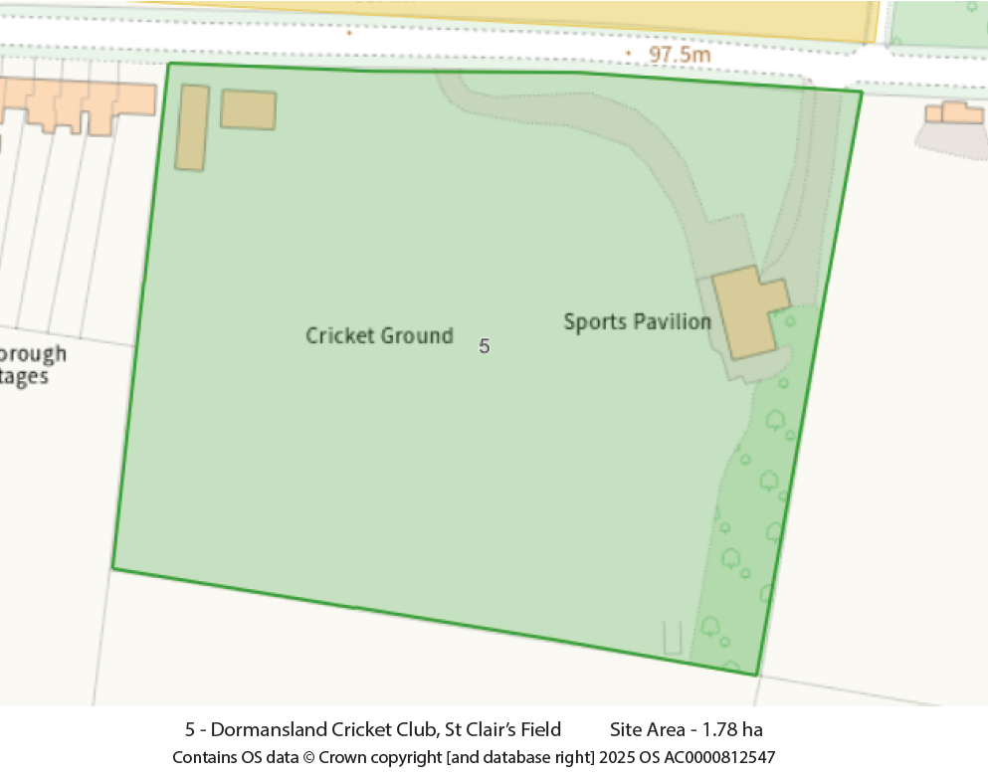
St Clair Cricket Ground – Location and extent

History
The land for the cricket club was gifted to the village by the St Clair family in 1880, for use in perpetuity as a cricket ground for the village and is owned and maintained by the Dormansland Cricket Club.

Assessment
Beauty (3a), Recreational Value (3c) and Tranquillity (3d)
Dormansland cricket club was established in 1880. The Club fields 6 teams: Saturday 1st XI & 2nd XI, Sunday 1st XI and 2nd XI, a midweek team and an indoor team. They play in the Mid-Sussex Cricket league and the Crawley indoor league. The ground is used for matches and for training purposes. Facilities include a full-sized cricket pitch and a fully equipped pavilion with a kitchen, bar and changing facilities.
The well-maintained ground is surrounded by mature trees and hedges, with an open view to the south. The setting is tranquil and verdant.

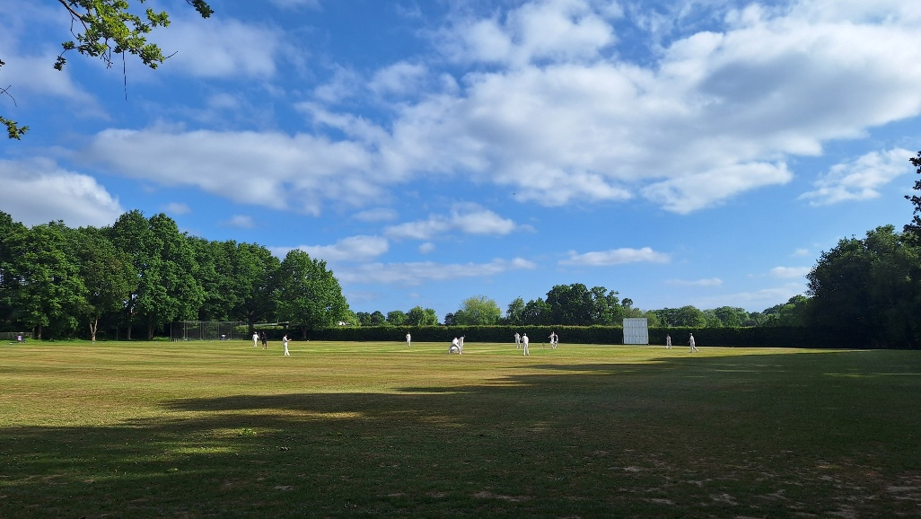
May 2025 from Dormansland Cricket Club Facebook Page

Site 6: Station fields
This truncated triangular piece of land is situated between Station Road, the railway line and Mill Lane.
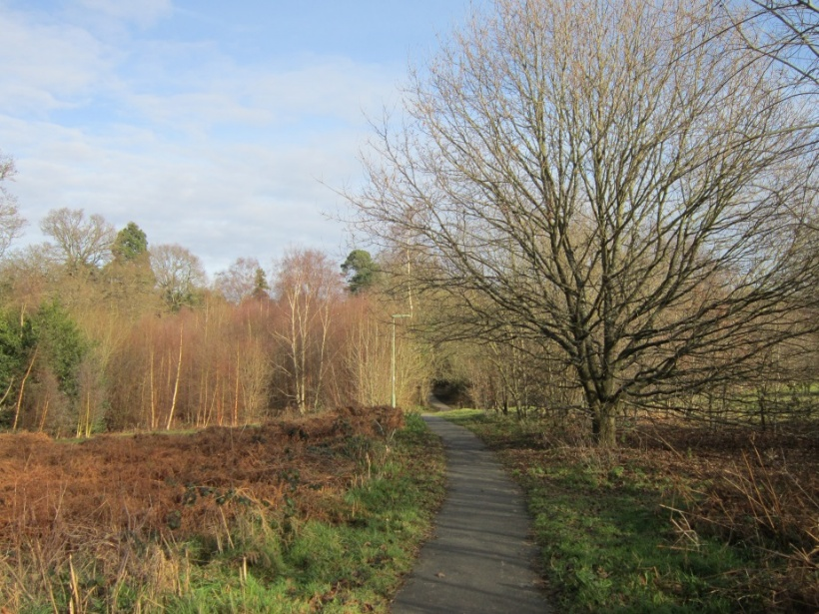
Path across Station fields, Dormansland (winter view).
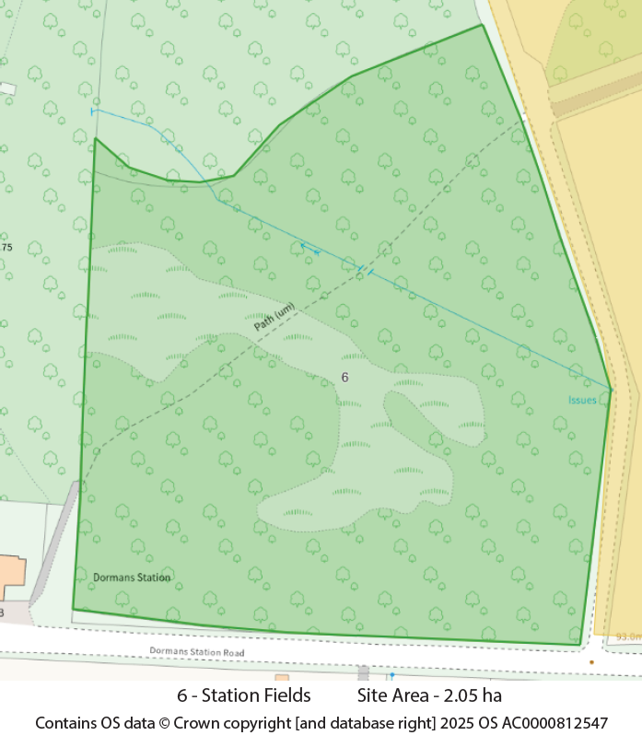
Station Fields – Location and extent
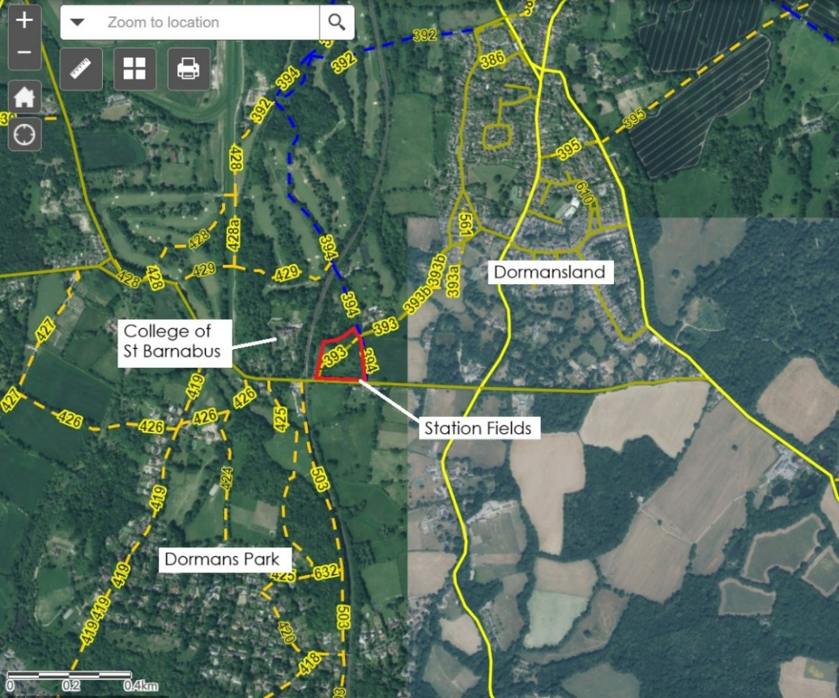
From the Surrey Interactive Map - Footpaths and bridleways around and across Station Fields outlined in red.

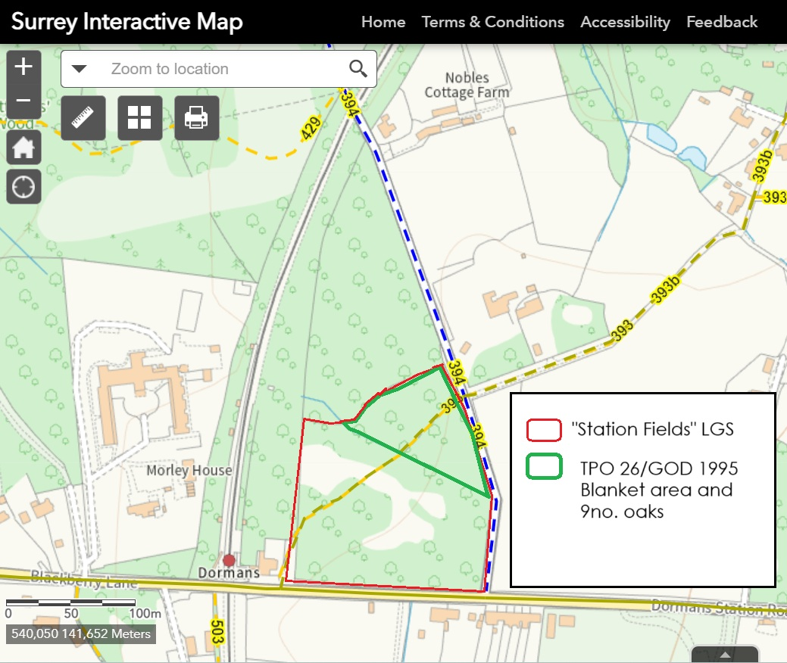
Station Fields from Surrey Interactive Map, showing area covered by TPO

History
These fields were originally used for pasture but over the last 30 years have largely reverted to scrub. The standing timber to the north of the site was clear - felled without a licence and has a Forestry Commission order to allow regeneration. Planning permission for housing on the site was refused 3 times between 1953 and 1957. Land adjacent to this site has planning permission for 9 houses and a car parking area (2017/212) to be located to the rear/north of the station. The footpath running through the site is a well-used route between the station, the College of St Barnabus, Dormans Park and the village. It is an “Adopted Highway” and is maintained by Surrey Highways.

Assessment
Beauty (3a), Recreational Value (3c), Tranquillity (3d) and Richness in Wildlife (3e)

This area forms part of a vital green corridor between Dormansland village and the railway station. It is crossed by a footpath from the Mill Lane bridleway to Dormans Station, which is regularly used by people travelling to work by train, by students travelling to school, other train users, dog walkers and residents of The College of St Barnabas retirement home for clergy. It is an integral part of the local network of public rights of way serving the wider area. The footpath is surfaced and is accessible to a wide range of abilities.

The site includes some very mature oaks as well as ash, hazel, hawthorn, holly, sallow, silver birch and Scots pine trees. The mature trees provide summer roosting for bats, and they are seen at night feeding over this nature rich location.
In April the following migrant birds arrive from Africa: chiffchaff, blackcap and willow warbler followed by whitethroat in early May. The chiffchaffs in some numbers spread right through from this field to the upper field bordering the railway. All our native birds can be heard and seen; especially robin, blackbird, thrush, 3 kinds of tits, goldfinch, green woodpecker, great-spotted woodpecker.
There is a wide variety of butterflies and in late June glow worms can be seen at dusk in the undergrowth. The mature trees provide summer roosting for bats, and they are seen at night foraging over the scrub areas. There is supporting evidence of these sightings.
The following plants have been recorded: birds-foot-trefoil, blackberry, bluebells, buttercups, bugle, clover, common agrimony, enchanters nightshade, ferns: shield, lady, male, buckler, golden scale, garlic mustard, germander speedwell, greater & lesser stitchwort, hemp agrimony, knapweed (hardheads), milkwort, ragwort, self-heal, sorrel, thistle, tormentil and violets.
With the constant passage of residents walking through or riding along the adjacent bridleway, this open space, whilst privately owned, is highly valued as a natural refuge and has been shortlisted by the Surrey Wildlife Trust as a potential site of conservation interest because of the undisturbed habitats within the site. Part of the site is already protected with a TPO (TDC/TPO 26/GOD 1995).
For homeward bound commuters from the station, it provides an intense experience of the countryside before entering the village, after travelling from London, Croydon or East Grinstead. It is a key feature on the 450 metres walk between the village and the station. For all pedestrians, this site provides a peaceful walk where everyone has the opportunity to experience nature up close.

The wider perspective
Dormansland village is dominated by its rural location and wonderful views to the Surrey Hills National Landscape (AONB), Ashdown Forest and High Weald National Landscape (AONB). The visual importance of the identified green spaces is vital to maintain the open character and rural feel of the village, justifying the continued “washing over” with Green Belt designation. They all have value for sports and other recreational activities, public access and regular use by those on foot, and maintaining an important visual green and open corridor through Dormansland into the surrounding countryside.

https://www.tandridge.gov.uk/Portals/0/Documents/Parks-Play-Areas/Clean-final-Open-Space-Strategy.pdf?ver=2021-03-10-132047-473
Adapted from the criteria used by Blandford Forum Neighbourhood Plan Green Spaces Study 2019 https://www.dorsetcouncil.gov.uk/documents/35024/284974/Local+Green+Spaces+Study+2019.pdf/77a35350-b617-2d82-f370-f301c9c1d72d .

